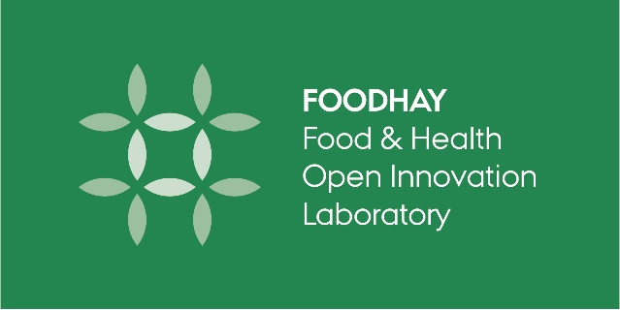

FOODHAY User Form**

I have used FOODHAY equipment
Which FOODHAY equipment are you using
Your name and email
The name of the organization / company you are employed at
The name of the organization where you are physically using the FOODHAY equipment
(AU FOOD, AU MAPP, DTI, DTU FOOD, KU FOOD, etc)
Are you doing A: Research or B: Teaching?
Fill in the relevant A/B box below

A: Research
Is your research in collaboration with partners?
Yes / no, If yes – please complete below
Are your collaborators research partners?
If yes – please name the ORGANISATIONS / UNIVERSITIES
Are your collaborators a company?
If yes – please name the COMPANY NAMES
Are your collaborators an authority / public body?
If yes - please name the AUTHORITY / PUBLIC BODY
Will your research deliver new knowledge (yes / no)
If yes – please specify outputs
Are you developing new methods, technology or processes (yes / no)
If yes – please specify

B: Teaching
Which FOODHAY equipment did you use / refer to?
Year course is taught
Organization name
(AU FOOD, AU MAPP, DTI, DTU FOOD, KU -FOOD, etc)
Name of education
(Bachelor in xxx, Master in xxx, Summer school in xxx)
Name of course
Type of course
(Undergraduate, graduate, summer school)
Contact Person (course responsible / lab technician etc) (name and email)

Thesis OUTCOME
Which FOODHAY equipment did you use?
Standard Acknowledgement in thesis | Data were generated though accessing research infrastructure at [AU/KU/DTU/DTI], including FOODHAY (Food and Health Open Innovation Laboratory, Danish Roadmap for Research Infrastructure).
Year thesis is submitted
Type of thesis
(Bachelor / Master / PhD)
Organization name
(AU FOOD, AU MAPP, DTI, DTU FOOD, KU FOOD, etc)
Title of Thesis
Name of student (no contact info is required)
Online link to thesis
Contact info of supervisor (name and email)

OUTPUT (popular article / peer reviewed publication / conference proceeding / video)
Which FOODHAY equipment did you use?
Standard Acknowledgement in articles / papers | Data were generated though accessing research infrastructure at [AU/KU/DTU/DTI], including FOODHAY (Food and Health Open Innovation Laboratory, Danish Roadmap for Research Infrastructure).
Year published / produced
Citation for publications
(Authors, Year, Title, Journal, Page numbers)
Online link to paper /video
Name of conference, if relevant

Event / Activity
Which FOODHAY equipment did you use/showcase?
Name of event
Type of event
(open day, drop-in meeting, training courses, technical workshop)
Target audience (who participated)
(Industry; large / SMEs / startups?
School students?)
Who organized the event?
Organization name
(AU FOOD, AU MAPP, DTI, DTU FOOD, KU FOOD, etc)

**This USER FORM is available online at https://food.au.dk/foodhay/user-reporting/
Please email your user forms to your FOODHAY contact person:
- AU MAPP: Jessica Aschemann-Witzel jeaw@mgmt.au.dk
- DTU FOOD: Heidi Kornholt heiko@food.dtu.dk
- DTI: Anne Louise Dannesboe Nielsen aln@teknologisk.dk
- KU FOOD: Nanna Viereck nav@food.ku.dk
- AU FOOD: Michelle Williams mw@food.au.dk

