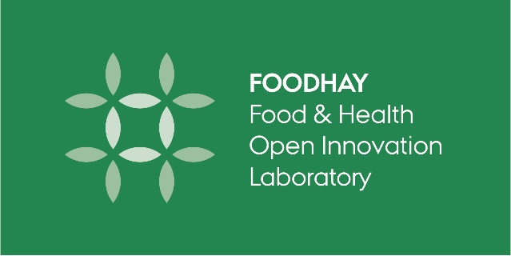

**FOODHAY User Form from 2024 \*\***

|  |  |
| --- | --- |
| **I have used FOODHAY equipment to support a PhD thesis:** | |
| **Standard Acknowledgement in thesis** | Data were generated though accessing research infrastructure at [*name the University: AU/KU/DTU*], including FOODHAY (Food and Health Open Innovation Laboratory, Danish Roadmap for Research Infrastructure). |
| **Student name** (no contact info is required) |  |
| **Year thesis was submitted** |  |
| **Title of Thesis** |  |
| **Name and email of supervisor** |  |

|  |  |
| --- | --- |
| **I have used FOODHAY equipment to publish a peer reviewed publication:** | |
| **Standard Acknowledgement in publications** | Data were generated though accessing research infrastructure at [*name the University AU/KU/DTU*], including FOODHAY (Food and Health Open Innovation Laboratory, Danish Roadmap for Research Infrastructure). |
| **Citation for publications**  (Authors, Year, Title, Journal, Page numbers)  See example of formatting:  <https://food.au.dk/foodhay/outputs/publications> |  |
| **Provide online link to publication** |  |

**This **USER FORM** is available online at <https://food.au.dk/foodhay/user-reporting/>

Please email your **user forms** to your FOODHAY contact person:

* AU MAPP: Jessica Aschemann-Witzel [jeaw@mgmt.au.dk](mailto:jeaw@mgmt.au.dk)
* DTU FOOD: Heidi Kornholt [heiko@food.dtu.dk](mailto:heiko@food.dtu.dk)
* KU FOOD: Nanna Viereck [nav@food.ku.dk](mailto:nav@food.ku.dk)
* AU FOOD: Michelle Williams [mhw@au.dk](mailto:mhw@au.dk)